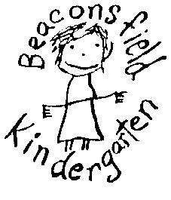
Beaconsfield Kindergarten
Bush Kinder Program

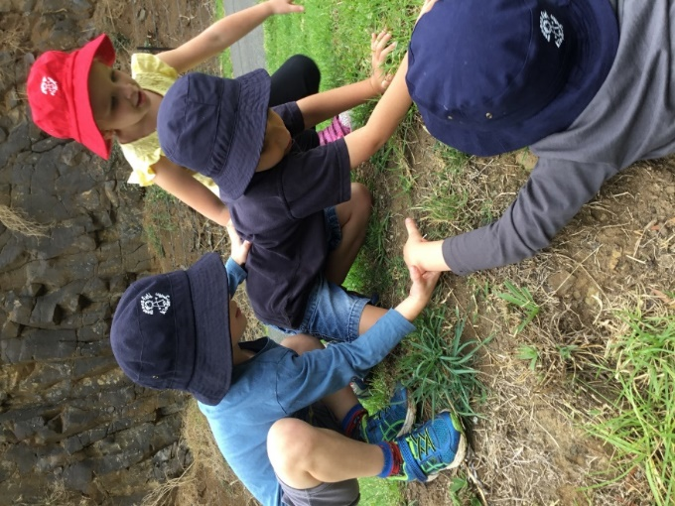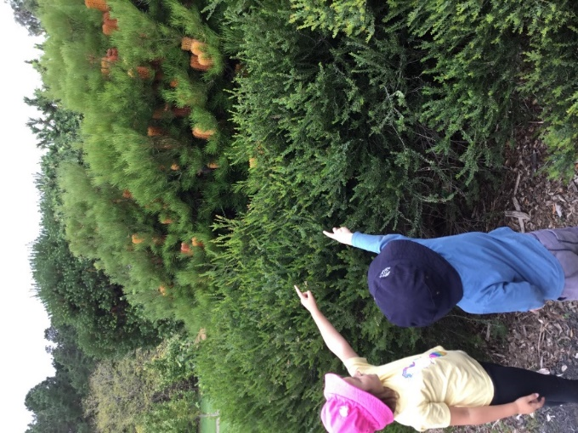

Beaconsfield Kindergarten is very excited to be announce we will be offering a Bush Kinder program as part of our funded (4yo) kinder program from 2019. This program will see certain kindergarten groups spending one session each week during Terms 2 and 3 in the Bush Kinder setting.

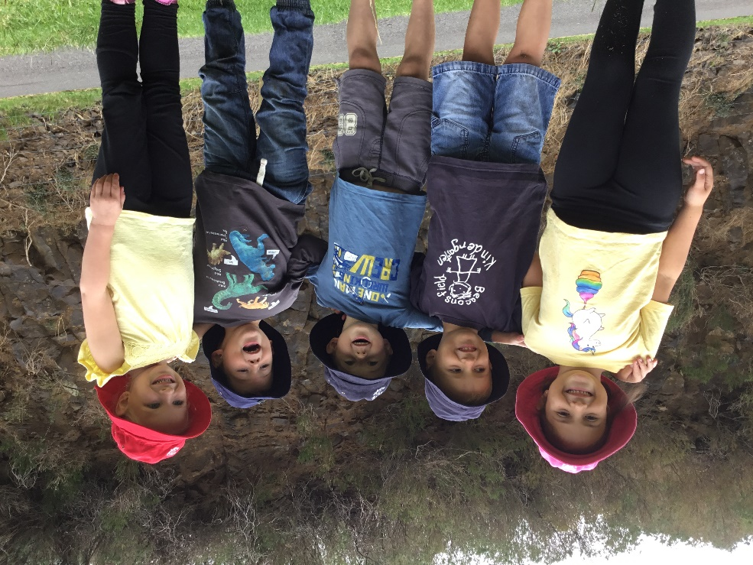
What is Bush Kinder?
A bush kindergarten is a type of preschool education for children that is held outdoors, allowing children to engage in a variety of activities that are typically not available in a traditional kindergarten setting. Whatever the weather, children are encouraged to play, explore and learn in a bush or natural environment. Physical activity is encouraged, and the children and adults benefit from using only what nature has provided. Bush Kinder recognises the place the bush has in Australian folklore and the significance of the land in aboriginal culture.

Bush Kinder and the Learning Program
The Victorian Early Years Learning and Development Framework (VEYLDF) uses five outcomes to describe the key elements of children’s learning and development. Bush Kinder can extend children’s learning and development in the following ways.
- Identity: Children develop a sense of security with familiarity. Regular sessions learning outdoors helps children build and explore their identity.
- Community: Through firsthand experience children develop an awareness of their impact on the local environment and can get involved in caring for nature.
- Wellbeing: Regular contact with nature relieves children’s minds and ignites curiosity. Outdoor environments allow children to expand and refine their abilities, mentally and physically.
- Learning: Ever changing outdoor environments invite hypothesising, imagination, interaction, problem solving and experimenting.
- Communication: Children can share stories, use natural materials to create art and interact with each other and their surroundings to create drama and music.
(source: Bush Kinder Handbook, Parks Victoria)
Furthermore, the Early Years Learning Framework for Australia states that play spaces in natural environments ‘invite open-ended interactions, spontaneity, risk-taking, exploration, discovery, and connection with nature. They foster an appreciation of the natural environment, develop environmental awareness and provide a platform for ongoing environmental education.’

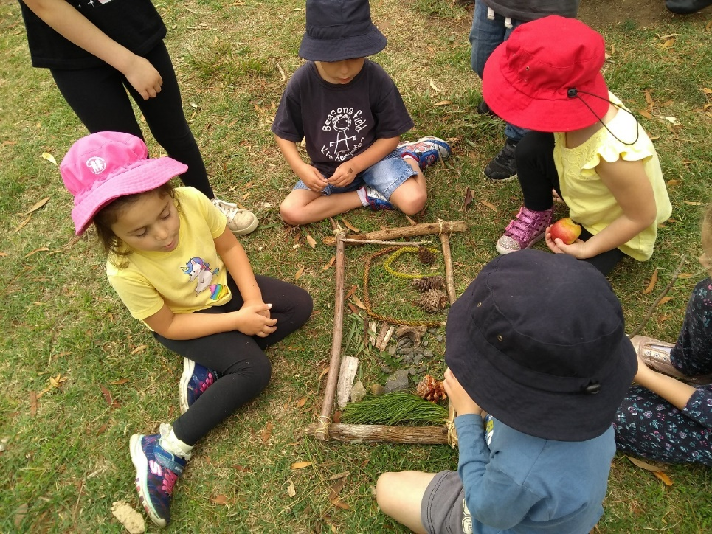

Beaconsfield Kindergarten Bush Kinder Program
At Beaconsfield Kindergarten, we want to give children a chance to spend quality time in nature with passionate teachers to encourage them to explore and learn. Learning in nature invigorates the senses, stimulates the imagination and nourishes wellbeing. By exploring nature, building cubby houses, climbing trees, splashing in puddles and playing games, the children are learning with their whole bodies.

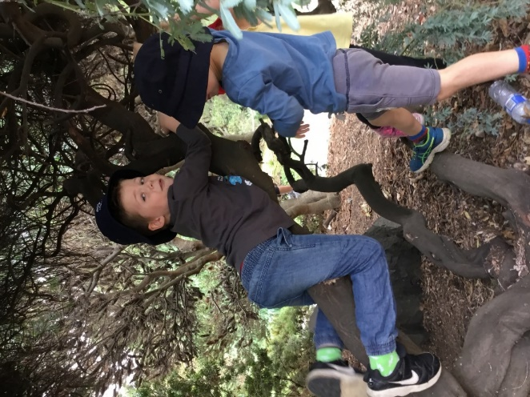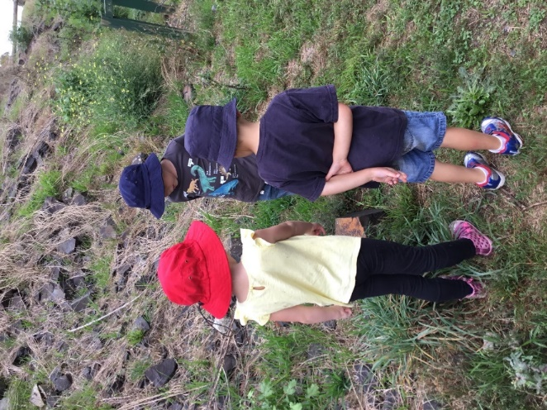

At Beaconsfield Kindergarten we believe in the importance of nature and outside play for children to learn and develop. Our Bush Kinder program supports the kinder’s overall philosophy, which promotes learning through play and embraces children’s creativity, self-expression, problem solving skills, language development, concentration and independence. We are committed to providing an environment which assists all members of the kindergarten community to experience physical, mental, emotional and social wellbeing. It has been shown that children who learn outdoors are less disruptive, show improved social skills, motor skills and physical health, and develop resilience, self-awareness, self-esteem and independence.

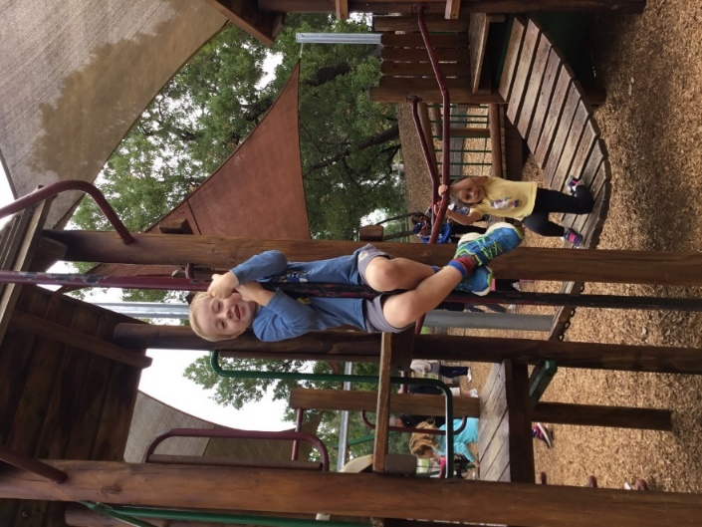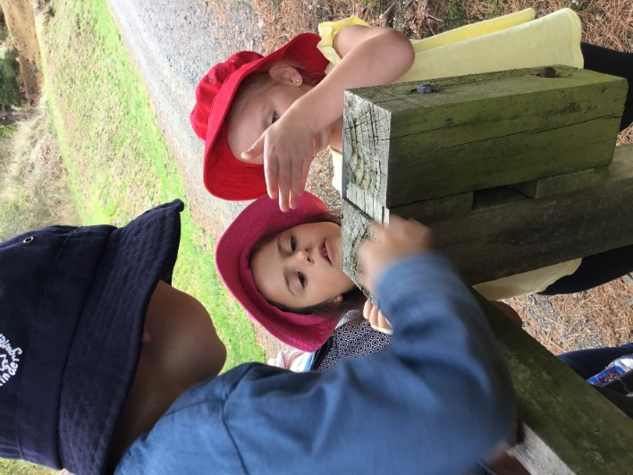

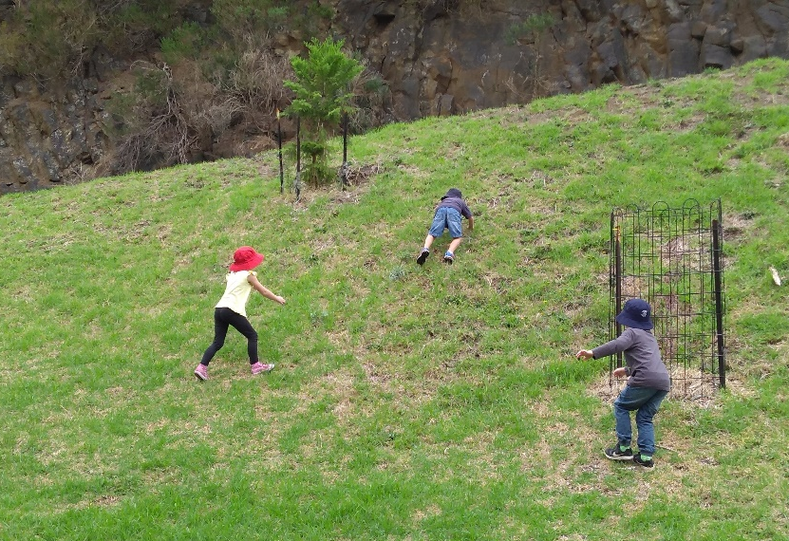

In 2019 Beaconsfield Kindergarten’s Bush Kinder program will be run at both Wilson Botanic Park and Akoonah Park. Children will attend one Bush Kinder session each week during terms 2 and 3. Families will be required to drop off and pick up from the Bush Kinder location.

